A

Project Report on

**WEBSITE ON KOLKATA CITY HELP**

**-A GUIDE TO NEWCOMERS**

Submitted in partial fulfillment of completion of the course

Advanced Diploma in IT, Networking and Cloud

Submitted by:

**Anoushka Das**

**Susma Kumari Singh**

Under Guidance of:

**Arpita Roy (Edunet)**

|  |  |  |
| --- | --- | --- |
|  |  |  |

Year 2022 -2024

Abstract

Acknowledgement

Team Composition and Workload Division

Table of Contents

1. Introduction to Problem

2. Proposed Solution

3. Requirements

3.1 Technology Stack

3.2 Hardware

3.3 Deployment Environment

4. User Requirements

5. Design Documentation

6. Implementation Details

7. Deployment

8. Conclusion

Appendix A Screenshot of Project

References

Abstract

There is no single website that can be rendered by citizens, tourists and outstation students for a particular city. This not only takes a lot of the users' time but also create confusion among them. Thus, the agenda is to provide a single window access to the information and services specifically for a city (Kolkata). We have a 4-page website to serve the purpose.

Acknowledgement

Team ‘Supernovas’ (comprising of 2 members, namely Anoushka Das & Susma Kumari Singh) are thankful to our teacher,Ms. Arpita Roy for her guidance and supervision which has provided a lot of resources needed in completing our project.

We are also thankful to the efforts put in by our team members and contributions to the preparation of this project.

Team Composition and Workload Division

Our team comprises of 3 members: Anoushka Das & Susma Kumari Singh.

* Anoushka Das: Member

Contribution: Conceptualization, topic research and second page (for Tourists) and documentation.

* Susma Kumari Singh: Member

Contribution: Overall project co-ordination, making homepage project design, third page (for Students) and About Us.

Table of Contents

1. Introduction to Problem: There is no single website that can be rendered by citizens, tourists and outstation students for a particular city. This not only takes a lot of the users' time but also create confusion among them.
2. Proposed Solution: "One stop solution” will be convenient, effective, efficient and reliable.

Moreover a 'user friendly 'website will not only help people explore Kolkata in a better manner but will also encourage more people to visit the city.

1. Requirements
   1. Technology Stack:

FRONT END: HTML, CSS, Bootstrap

BACK END: PHP, MYSQL

* 1. Hardware:

Device name DESKTOP-VDV25SG

Processor Intel(R) Core (TM) i7-8700 CPU @ 3.20GHz 3.19 GHz

Installed RAM 16.0 GB (15.8 GB usable)

Device ID F15CC3EA-F8F5-4986-A23B-2D4800C276E9

Product ID 00330-51616-71380-AAOEM

System type 64-bit operating system, x64-based processor

* 1. Deployment Environment:

InfinityFree

4. User Requirements:

Tourists and outstation students.

5. Design Documentation

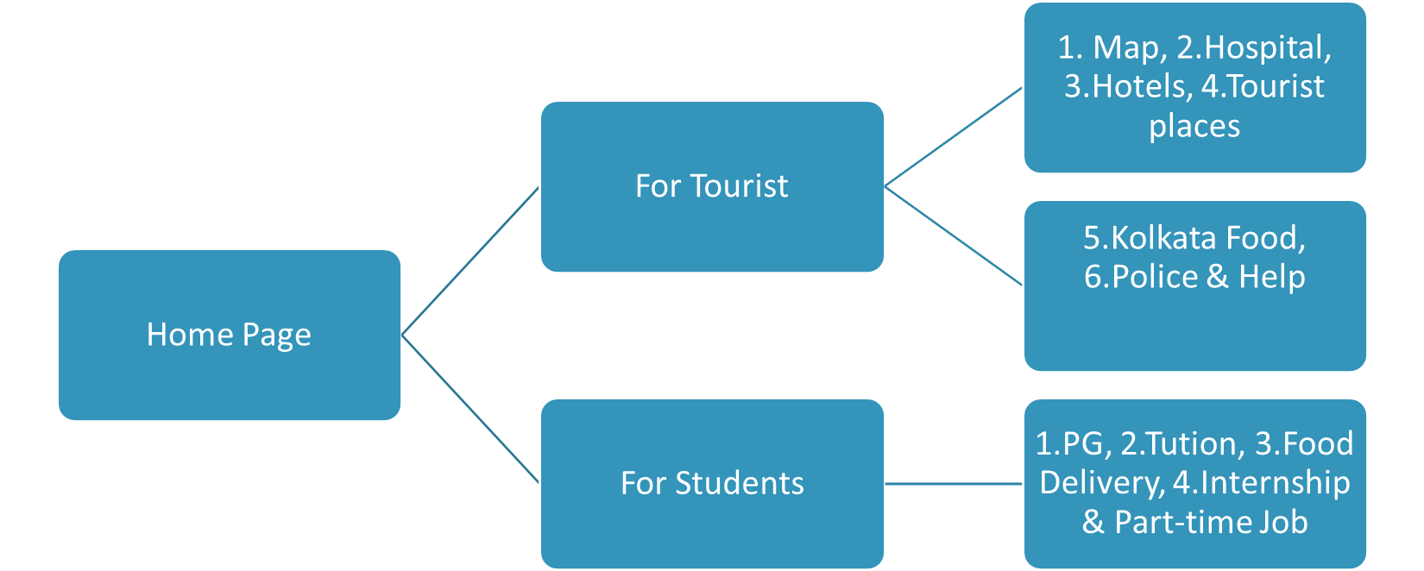

6. Implementation Details

The website has 5 pages.

The first page is the Main page or Homepage. It is the page which is viewed at first by the users. This page has all the necessary introductory details and has been linked to the other pages.

The second page is entirely allotted for tourists and thus has information they should be aware of such as -a map for navigation, Places to visit, hospitals nearby, Police and help in case of an Emergency and authentic food in Kolkata.

The third page is entirely for students and consists of details such as tuitions nearby, Part-time job, PG, Home food delivery, etc.

The last page is About Us. This page consists about our approach and this website. This page also holds the details of our team members who have worked together to make this website come into existence.

We have used a chatbot for our website that will help the users in better understanding and better exploring of the website and the places mentioned within.

7. Deployment

InfinityFree

InfinityFree is probably the best web hosting you can get for nothing and it comes with no expiration date. Its one-and-only solution includes some of the neat features you would usually expect to get with commercial-level hosting only, such as unlimited disk space, (almost) unlimited bandwidth, industry-standard cPanel and the Softaculous one-click installer.

8. Conclusion

We have provided assistance and information about Kolkata. In the hope that it helps tourists, students or anyone traveling to Kolkata for the first time. We not only save time but also save people from falling prey to misleading information. We have provided contacts and other information through verified source and aim to reach out to more people.

Having a user friendly website and a single interface which lists various citizen services (some of which are offered by the state government) and other services makes it "one stop solution”.

Appendix A : Screenshot of Project

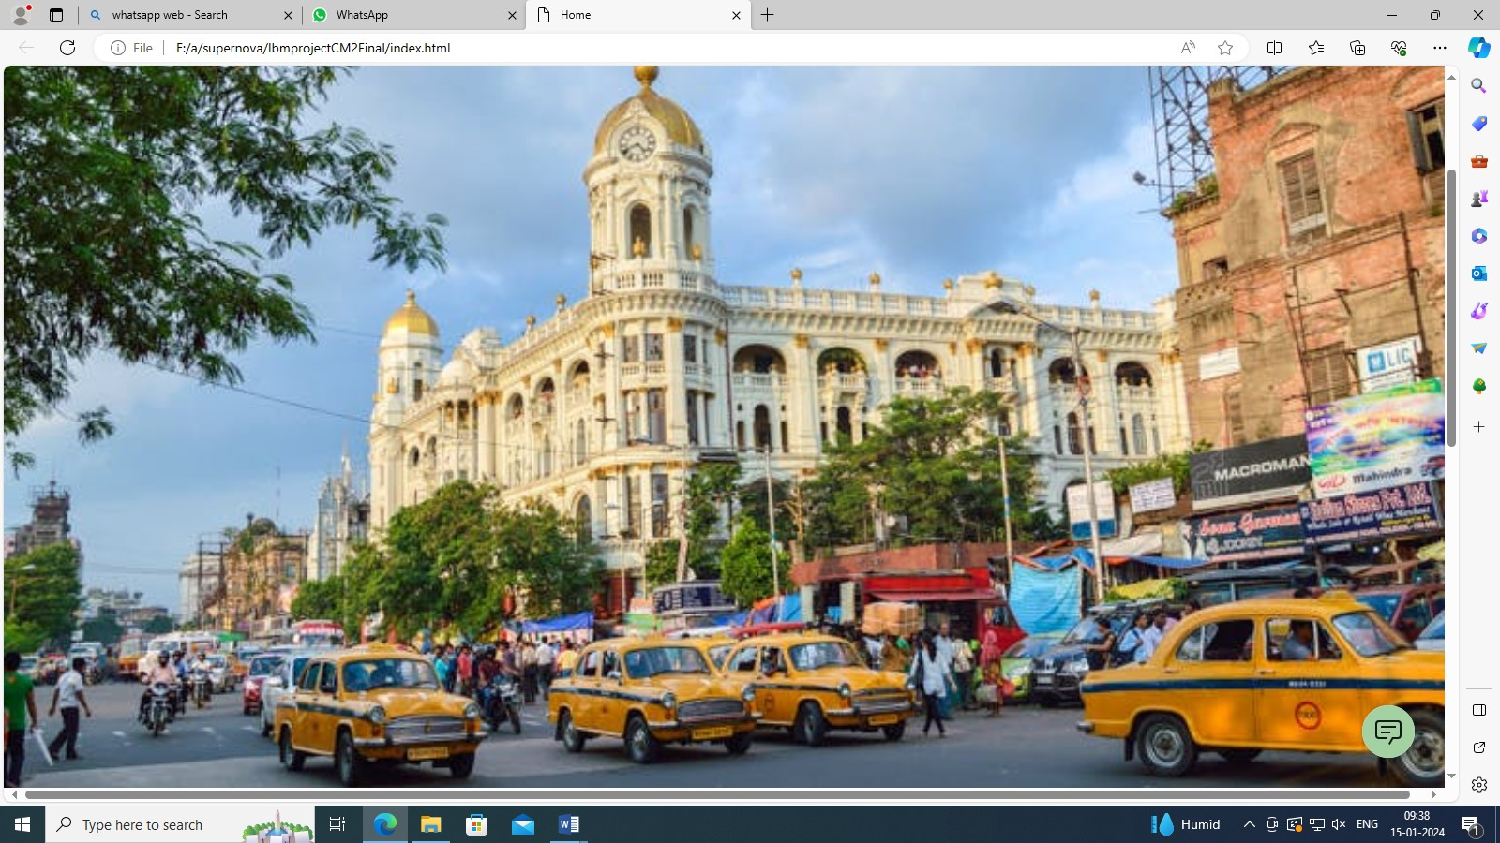

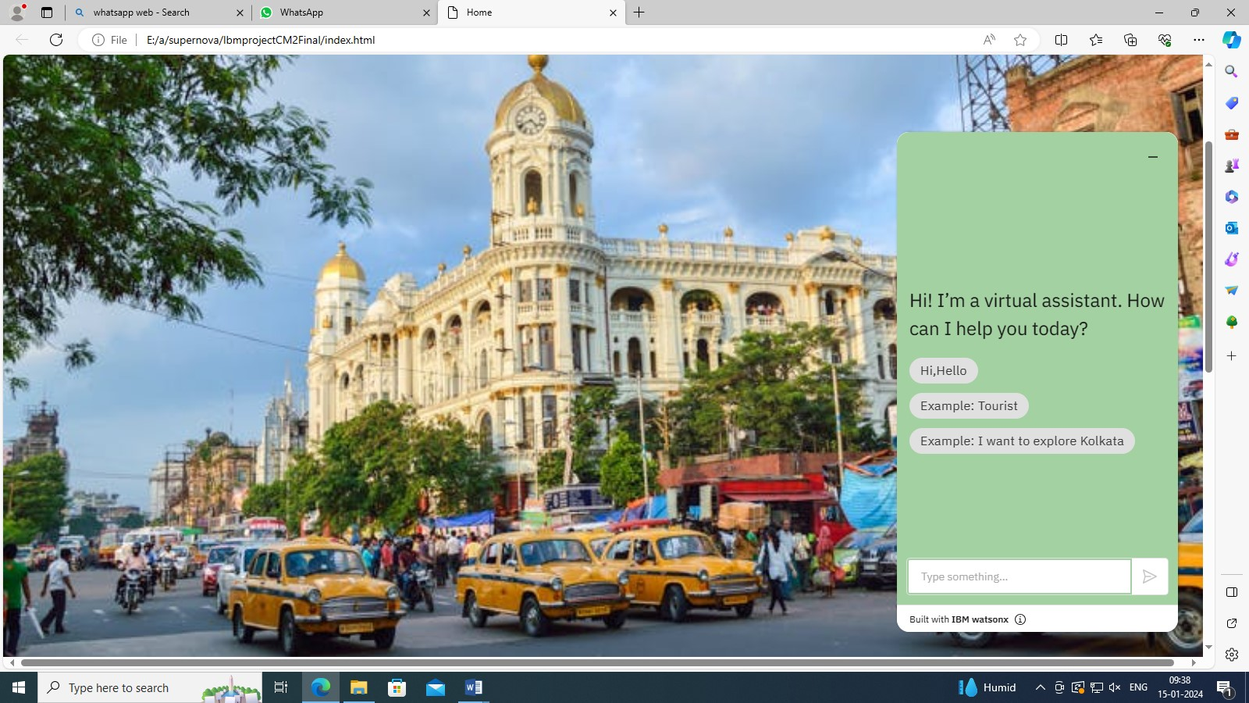

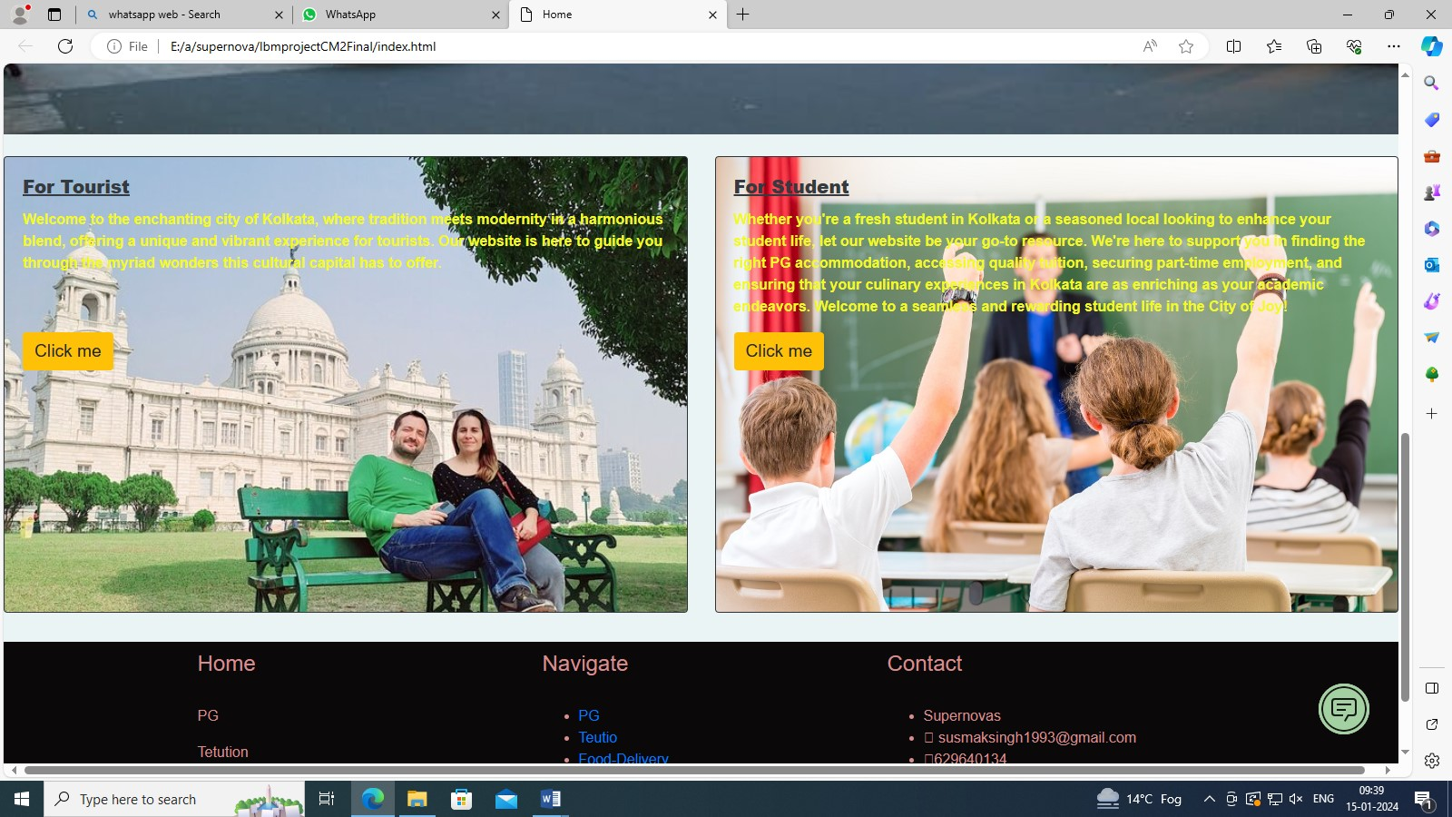

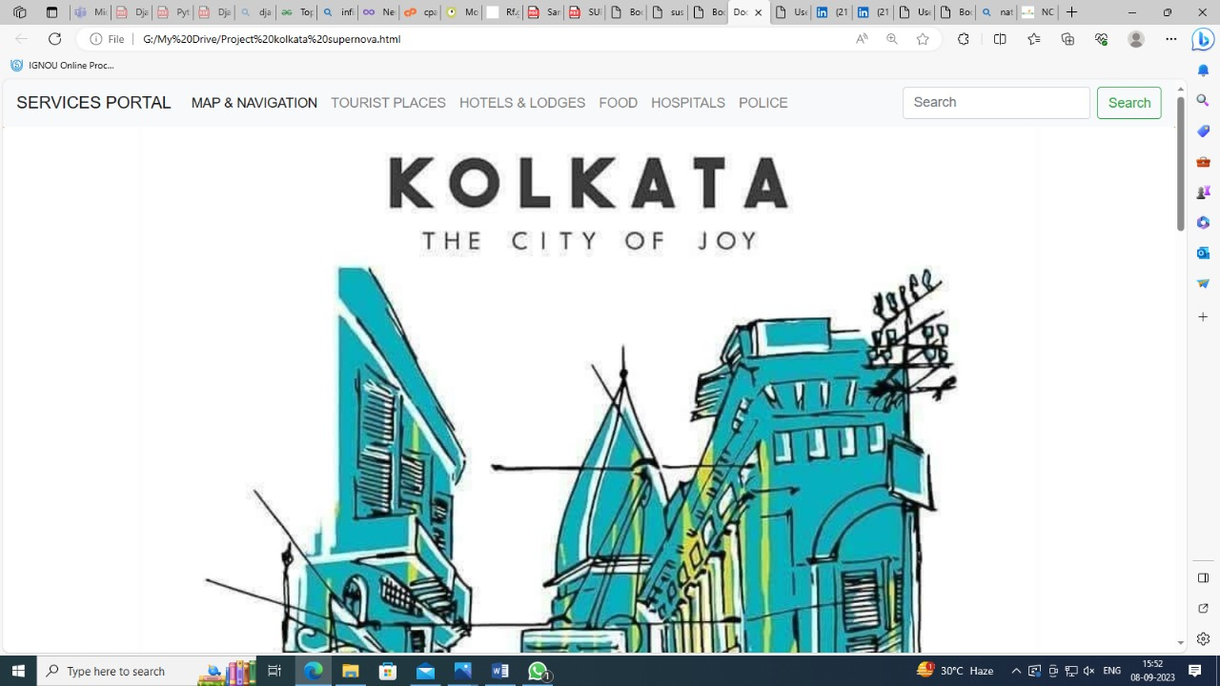

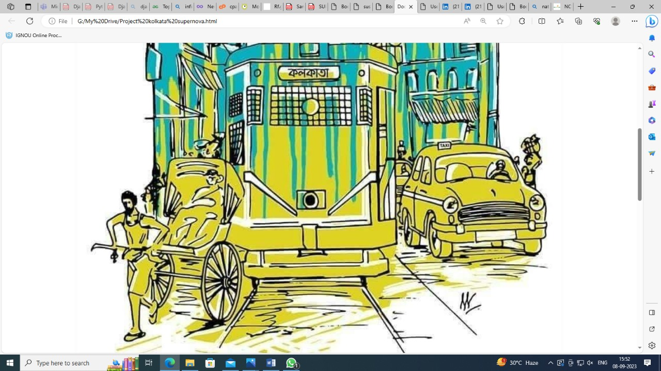

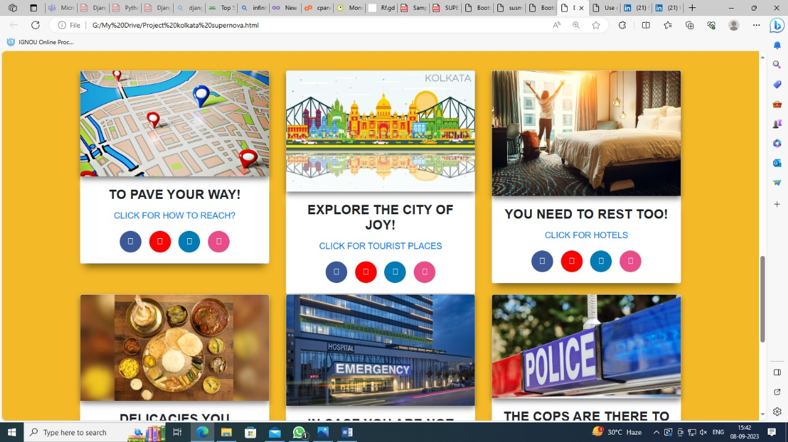

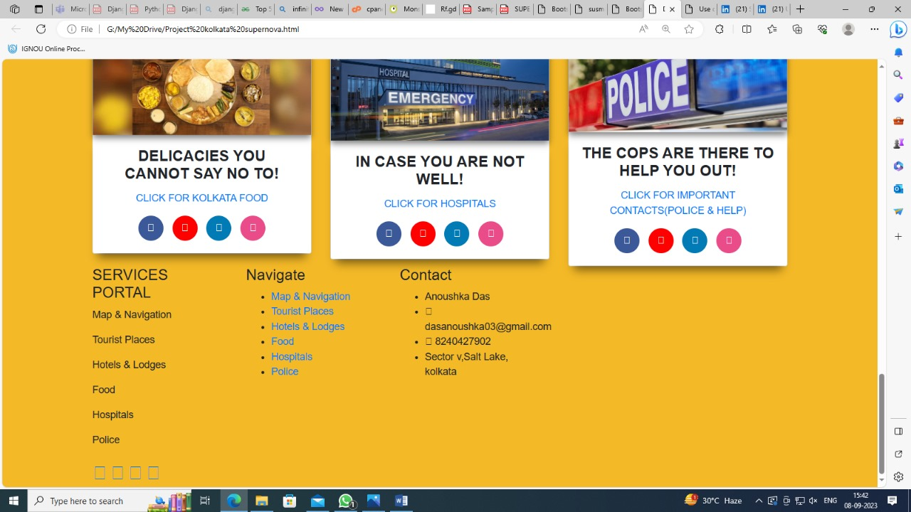

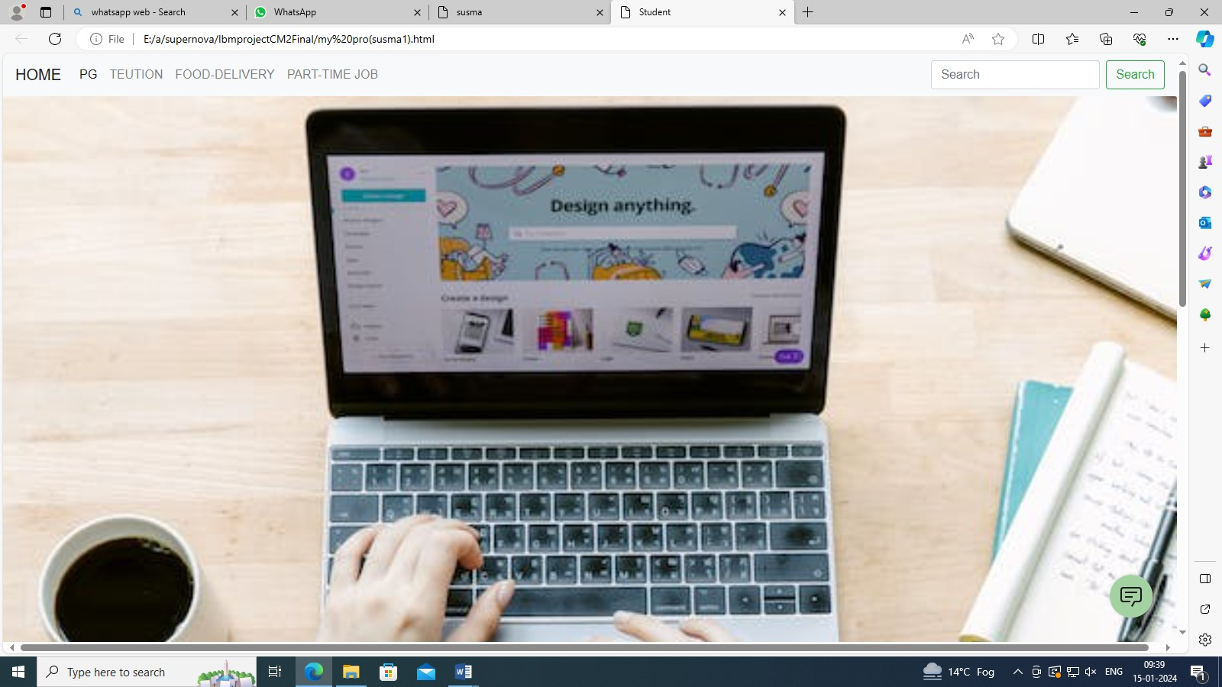

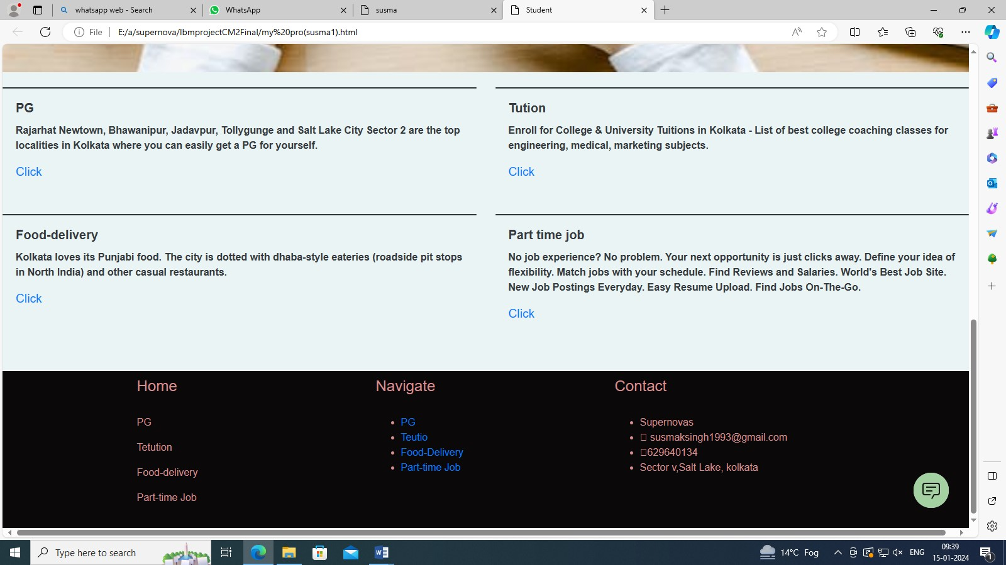

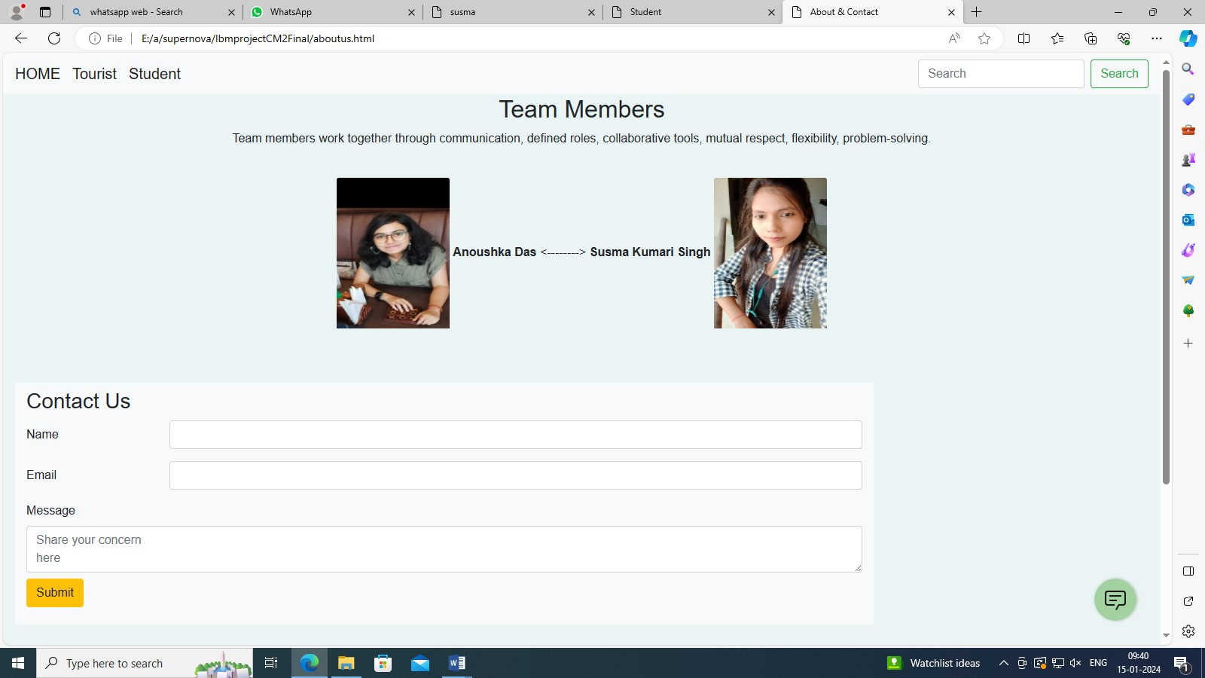

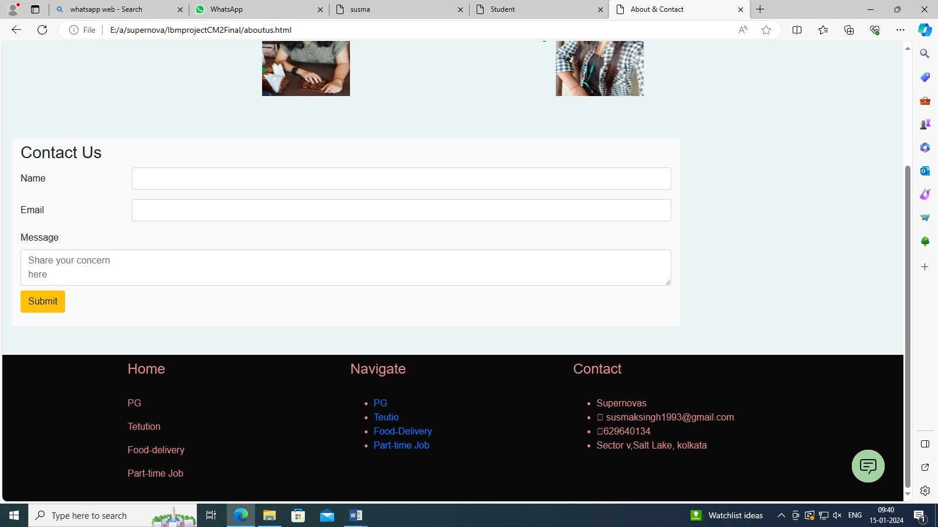

References

* [www.google.com](http://www.google.com)
* <https://www.wbpolice.gov.in>
* [www.zomato.com](http://www.zomato.com)
* [www.tripadvisor.com](http://www.tripadvisor.com)
* [www.policybazaar.com](http://www.policybazaar.com)